***SESG6039 – Composites Engineering Design and Mechanics - Individual Assignment 2***

***Name:*** *Abhinandan Thour* ***Student ID:*** *32453515*

The objective of this report is to provide a detailed description of the experimental procedure conducted in the laboratory and the subsequent analysis of the acquired data.

Describing the Tensile Testing Procedure:

In the video lab illustrating the Tensile testing of composite test specimens, the tensile tests were conducted following the BS EN ISO 527-5:1997 standard. A total of 6 type-2 specimens were prepared, with three specimens obtained utilizing Prepreg manufacturing process and three produced through Resin Infusion. Both specimen types adhered to a lay-up sequence of 12 plies [-45 45 90 0 90 0]s.

The Tensile Testing proceeded as follows:

* + The thickness and width of each specimen were measured at three points along their length, and the calculated averages were employed to enhance measurement accuracy.
  + The specimen designated for testing was securely mounted in the grip of the Tensile Test machine, as shown in Figure 1.
  + The tests were conducted utilizing an electro-mechanical 5500 Instron machine, and a 50 mm long gauge extensometer which was fixed to the specimen to obtain more precise strain values.
  + Subsequently, a tensile load in the fibre direction was applied, maintaining a constant displacement rate of 5 mm/min, and data was collected.
  + The test machine was set to pause at 15 kN to facilitate the extensometer being removed before failure of the specimen.
  + The test continued until the specimen failed.
  + Post-test, data was collected & analysed.
  + The entire testing sequence was repeated for the remaining specimens.

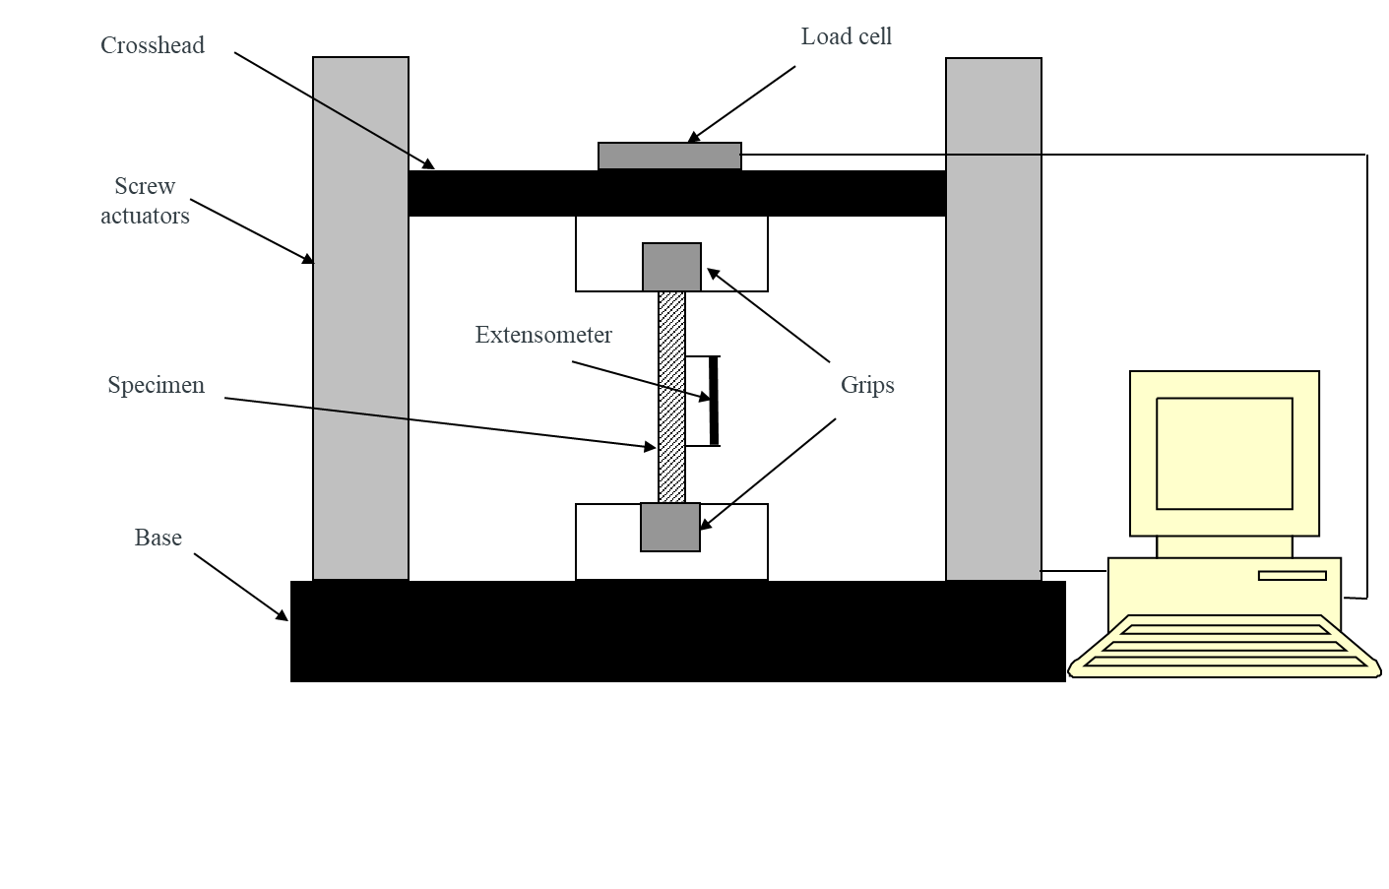

Figure 1 - Schematic of the test setup of a typical test machine

Describing the Analysis of the results Procedure:

* The output from the testing machine included time [s], load [N], and displacement [mm], whereas the extensometer yielded a more precise measurement for strain [mm/mm]. These data were compiled into an Excel file, and subsequent data analysis was conducted. Prior to graph plotting, a preliminary visual inspection of the data was undertaken as a precautionary step to identify any errors or discrepancies that could potentially influence the subsequent analysis and results.
* For specimens PP2, INF2, and INF3, an observation was made that the strain initially exhibited negative values. This phenomenon could be attributed to a potential incorrect reset of the Extensometer and the Tensile Test machine, resulting in the failure to establish a baseline strain value of 0 when starting the tensile test. An alternative explanation could involve difficulties in securing the Extensometer to the specimen's surface accurately. Given that the specimen has a smooth surface on one side and a rough surface on the other, vibrations during the Tensile Test may have moved the Extensometer during the testing process.

The negative strain values are inconsistent with the nature of tensile testing, as it implies a compressive force, which the machine is not designed to exert. To rectify this discrepancy and maintain uniformity across specimens, the recorded values were offset to start from 0, thus ensuring consistency in subsequent analysis. In addition, all the strain value commencing from a position higher than zero were offset to zero.

* To determine Ex exclusively within the linear region requires the calculation of the stress, the stress endured by the specimen was obtained by dividing the applied load by the cross-sectional area [Table 1] of the specimen.
* Upon obtaining the stress and strain values, a stress-strain graph was generated following the parameters in the BS EN ISO 527-5:1997 standard. The slope of the linear portion of the graph was used to calculate Ex, with the average of Ex in that segment representing the final tensile modulus.
* For the calculation of Failure Stress (Xt) and Failure Strain (ϵtx), the point of maximum stress or the occurrence of a noticeable decrease in stiffness (in the case of vacuum resin infusion) was identified as the reference point for assuming the initiation of first ply failure.

Six different Test specimen underwent testing, with three dimensional measurements taken at different locations on each specimen. By averaging these three measurements, a ply thickness value was determined. This derived ply thickness value can then be applied in the Classical Laminate Plate Theory (CLPT) code to obtain the engineering properties of the composite material.

|  |  |  |  |  |  |
| --- | --- | --- | --- | --- | --- |
| *Test specimen* | *Width [mm]* | *Average Width value [mm]* | *Thickness [mm]* | *Average thickness value [mm]* | *Average Cross-Sectional Area [mm^2]* |
| PP1 | 25.60 / 25.53 / 25.56 | 25.563 | 2.74 / 2.74 / 2.74 | 2.740 | 70.04353 |
| PP2 | 25.60 / 25.54 / 25.58 | 25.57 | 2.90 / 2.73 / 2.73 | 2.787 | 71.26436 |
| PP3 | 25.27 / 25.11 / 25.30 | 25.23 | 2.78 / 2.75 / 2.78 | 2.770 | 69.87787 |
| INF1 | 25.02 / 24.85 / 25.21 | 25.03 | 3.57 / 3.52 / 3.56 | 3.550 | 88.84467 |
| INF2 | 25.19 / 24.29 / 24.52 | 24.67 | 3.58 / 3.57 / 3.58 | 3.577 | 88.22444 |
| INF3 | 25.40 / 25.37 / 25.33 | 25.37 | 3.55 / 3.49 / 3.60 | 3.547 | 89.96711 |

Table 1 - Dimensional Specimens values

The obtained values for Ex and Ey using the CLPT code for the following symmetrical configuration of [-45, +45, 90, 0, 90, 0, 0, 90, 0, 90, +45, -45] are shown in Table 2. Ey and Ex are identical since the tested laminate is a quasi-isotropic laminate.

|  |  |  |
| --- | --- | --- |
| *Test specimen* | *Ex & Ey [MPa]* | *Ex & Ey [Pa]* |
| PP1 | 22557 | 22557192006.451 |
| PP2 | 22557 | 22557192006.451 |
| PP3 | 22557 | 22557192006.451 |
| INF1 | 20824 | 20823548217.496 |
| INF2 | 20824 | 20823548217.496 |
| INF3 | 20824 | 20823548217.496 |

Table 2 - CLPT Ex & Ey in MPa and Pa

To derive the engineering properties, the experimentally collected data can be presented graphically. However, adhering to the EN ISO 527-4:1997 standard, certain manipulations are necessary. The standard recommends establishing a starting strain value of 0.0005 and a finishing value of 0.0025. This ensures that the data points selected for analysis are conducive to forming a linear line for the calculation of Ex.

Given the use of wedge grips in our testing, which tend to settle more as the load increases, some initial data points may need to be excluded due to non-linearity caused by the grips not being fully settled on the specimen. Additionally, certain data points may be discarded where rapid changes in strain occur, signifying the initiation of fibre breakage before complete specimen failure. This approach is essential to ensure the accuracy and appropriateness of the data selected for the linear analysis to calculate Ex.

Ex can be obtained by plotting the trendline on the graph as shown Figure 2.

Figure 2 - Pre Preg & Resin Vacuum Infusion Specimen Stress/Strain Graph

|  |  |  |
| --- | --- | --- |
| *Test specimen* | *Slope Equation* | *Max load [MPa]* |
| PP1 | y = 24688x + 7.0489 | 34783.44531 |
| PP2 | y = 23593x + 6.5940 | 34492.71484 |
| PP3 | y = 23271x + 6.7616 | 34282.09766 |
| INF1 | y = 15852x + 2.0888 | 28227.24805 |
| INF2 | y = 18466x + 2.4622 | 27094.32813 |
| INF3 | y = 19357x + 1.2641 | 28339.36133 |

Table 3 - Slope Equation and Max Load for each Specimen

The Failure Stress (Xt) can be calculated by dividing the failure or maximum load by the cross-sectional area of the specimen. Once this value is obtained, it can be substituted into the slope equation, solving for strain (x), to determine the failure strain.

|  |  |  |  |
| --- | --- | --- | --- |
| *Test specimen* | *Ex [MPa]* | *Xt [MPa]* | *εtx [mm/mm]* |
| PP1 | 24688 | 496.5975 | 0.01982 |
| PP2 | 23593 | 484.0107 | 0.02023 |
| PP3 | 23271 | 490.6002 | 0.02079 |
| INF1 | 15852 | 317.7146 | 0.01991 |
| INF2 | 18466 | 307.1068 | 0.01650 |
| INF3 | 19357 | 314.9969 | 0.01621 |

Table 4 - Experimental Ex, Xt and εtx

The data obtained has also variations due to the utilization of different resins for prepreg and vacuum resin infusion, namely RP-528 and Prime 27, respectively. While the primary load-bearing responsibility lies with the E-Glass fibres, the influence of the resin is visible, introducing slight differences, as illustrated in Table 5.

Comparing manufacturing processes, Prepreg manufacturing involves pre-impregnating fibres for precise resin content, ensuring uniformity. Resin vacuum infusion uses dry fibres and infuses resin in a mould, allowing flexibility in fibre orientation. Complications like voids and uneven resin distribution can impact material properties in both processes, but careful control in prepreg ensures consistent quality, while resin infusion offers versatility in design.

|  |  |  |  |  |
| --- | --- | --- | --- | --- |
| *Manufacturing Process* | *E1 [GPa]* | *E2 [GPa]* | *V12* | *G12 [GPa]* |
| PP [E-Glass & RP-528] | 41.33 | 10.94 | 0.36 | 3.60 |
| INF [E-Glass & Prime 27] | 38.98 | 7.18 | 0.26 | 5.09 |

Table 5 - Material Properties for different specimens

E1, the longitudinal modulus reflects the material's resistance to deformation in the direction of the aligned fibres, and an increase in E1 corresponds to greater stiffness and rigidity in that direction. A higher E1 is a contributing factor that increases the Young's modulus for Prepreg specimens.

The following graph in Figure 3 illustrates the material behaviour under tension using values obtained while the extensometer was attached to the specimen, covering the load range from 0 kN to 15 kN. The graph indicates that specimens subjected to the Resin Vacuum Infusion process exhibit a lower Young’s Modulus, showcasing more elastic and flexible material properties. This observation is further corroborated by Figure 4, where the failure mode for Resin Vacuum Infusion is characterized as ductile.

Figure 3 – Stress Strain graph for specimens undergoing tension until 15kN.

Figure 4 – Full Tensile Test Stress Strain Graph

The tensile stress machine, 5500 Instron machine records extension in addition to the Extensometer, as strain is:

$${Strain}_{machine}=\frac{Final Lenght-Intial Lenght}{Initial Lenght}=\frac{Extension}{Initial Lenght}$$

We can calculate this machine-calculated strain and plot it against the machine-calculated stress (Load/Area) to visualize the material behaviour. This graphical representation, as shown in Figure 4, enables us to observe the characteristics of the material's response to loading and provides insights into the type of failure that occurred, brittle (PP) and ductile failure (INF).

Proceeding to the comparison between CLPT and Experimental data a clear trend can be seen.

|  |  |  |  |
| --- | --- | --- | --- |
| *Test specimen* | *Ex [MPa] - Experimental* | *Ex [MPa] - CLPT* | *Error %* |
| PP1 | 24688 | 22557 | 9.447% |
| PP2 | 23593 | 22557 | 4.593% |
| PP3 | 23271 | 22557 | 3.165% |
| INF1 | 15852 | 20824 | 23.876% |
| INF2 | 18466 | 20824 | 11.323% |
| INF3 | 19357 | 20824 | 7.045% |

Table 6 - Result Comparison between Theoretical and Experimental Properties

In analysing the obtained results from both experimental and theoretical data, it is observed that, for each Pre-Preg specimen, the value of Ex is consistently higher. This discrepancy can be attributed to a possible positioning the 45-degree laminas at not exactly at the right angle but closer to the loading axis for the tensile test. This arrangement results in a greater fibre presence to resist the load, consequently leading to the higher values of Young’s modulus.

In the three tests conducted for the Resin Vacuum Infusion, the experimental values consistently fell below the corresponding theoretical values. This disparity is likely primarily due to the presence of voids within the test specimens or areas with an excess of resin, both of which can compromise the mechanical properties of the laminate.

Examining the typical stress-strain graph, the Pre-Preg laminate exhibited a brittle failure, higher stiffness, and a good bond between fibres, aligning with expectations owing to its lower void content manufacturing process compared to Vacuum Resin Infusion, which displayed a more ductile failure.

For both cases, various factors could contribute to obtaining lower values compared to the CLPT, including incorrect fibre alignment, the presence of voids, variations in fibre thickness within the lamina, and potential manufacturing process deviations such as a vacuum valve leak. This latter could influence the establishment of the required vacuum, compromising resin distribution throughout the laminate and leading to premature failure during the tensile tests. Additionally, excessive clamping force might induce higher stresses at the edge, contributing to the expected lower values than theoretical values due to weaking the laminate.

Furthermore, for this test the volume fraction was assumed to be 0.5, measuring the actual volume fractions for each infusion specimen could have provided additional information and confirmation regarding any deviation from the theoretical value.

It's worth noting that the Classical Laminate Theory (CLT) assumes perfectly bonded laminae with infinitesimally thin bonds and no shear in through-thickness deformation. These assumptions result in continuous displacements through lamina boundaries and, consequently, no slip between plies. Therefore, CLT tends to overestimate properties, providing values larger than the experimental ones.